Date: 29th March 2022
Event Report

School / Functional Department / Club Name |  |  |  | School of Engineering and Technology (SoET)/CAMD
Event / Program Title |  |  |  | Visit of School students/ Scientific social responsibility
Nature of Event (Seminar/Workshop  /Conference/Training/MDP/FDP/Cultural/Technical) |  |  |  | Visit of School students to CAMD lab, BML Munjal University under SSR for SERB funded project on Dye water remediation
Name of Resource Person(s) and Contact Details |  |  |  | Dr Suchitra Rajput Chauhan, Centre for Advance Materials and Applied Science,
Description  (200 Words max.) |  |  |  | Date- 29-March 2022  Duration of Visit- 8 to 11:30 AM  Number- 44 (Raman Munjal School including two teachers) + 2 (Delhi Public School, Rewari)  Activities for school students during visit :  1. CAMD visit including interaction with faculties and research scholars on the research work undertaken along with the small poster/ppt presentation on the associated SERB funded project (Dye contaminated water remediation)  2. Snacks Time +Drawing based on the theme (paper/pencil/crayons were provided)- Venue (E2 cafeteria)  PLAN:  Step1 (8:15- 8:30am)- Students divided in two batches (Batch1, Batch2) - #20+ ,each batch was further divided in small groups of 4 students (Volunteer-Ms. Darshika and Jyoti-Volunteers) + Attendance was taken Batch wise(Volunteer-Ms. Dashika & Ms. Jyoti) + NeckTag Provided to students batchwise(Volunteer-Ms. Anchal).  Step2 (8:31- 9:15am)- Batch1 visited the lab in groups (staff-Mr. Kaushlesh)+ Batch2 - Drawing (Volunteer-Ms. Jyoti)  Step3 (9:16- 10:00am)- Batch2 visited the lab (staff-Mr. Kaushlesh)+ Batch1 - Drawing (Volunteer-Ms. Jyoti)  Step4 (10:01- 10:30am)- Both Batch completed theme-based drawing + Snacks (All Volunteers and CAMD Faculty)  Step4 (10:31- 10:45 am)- Photograph with Dean Sir and VC Sir and all participants (staff-Kaushlesh)  Step4 (10:31- 10:45 am)- Departure of Students  Organizing Team:  1. CAMD Faculty interacted with students and explained their research work (Prof Sridharbabu, Prof Shambhu Nath Bera, Dr Abhimanyu Rana, Dr Sanmitra Barman, Dr Vishal Baloria, Dr Amarnath, Dr Suchitra Rajput Chauhan)  2. Research scholars working in CAMD interacted with students and explained their PhD research work (Darshika, Anchal, Sumit, Jyoti, Ritika)  3. Volunteers- Mr. Piyus (ensured lab opening before 8 available in Thin film section, ensure safety of students), Mr. Naresh (available in measurement section, ensured the safety of students, Mr. Kaushlesh completed the printing of Poster and photographs  4. Dean Sir (prof. Anirban) was the judge and handed over the Prizes to the students  5. Snacks Arrangement- Mr. Pushpendra Yadav (Manager D'cafe)  6. Mr. Dalip- Arrangement for 60 people in E2 Cafetaria  Outcome of Visit:  1. SSR activity of SERB Project (Awareness about the initiative in the direction of waste-water remediation)  2. Interaction and one-to-one sessions with research scientists researching in various fields.  3. BMU Branding, projection of high-end facility of CAMD lab.
From  (DD-MM-YYYY) | To  (DD-MM-YYYY) | Number of Participants |  |  | Expenses Incurred | Revenue Generated
 |  | Faculty/Staff /volunteers | Students
29-3-2022 | 29-3-22 | 7/3/5 +  1-Dean, and VC Sir | 44+2 teachers from School |  | 10,000 Rs | Nil
Geotagged photographs for offline events / Screenshots for online events
Caption: Group photograph of students, and teachers with organising team member and VC Sir | Caption:
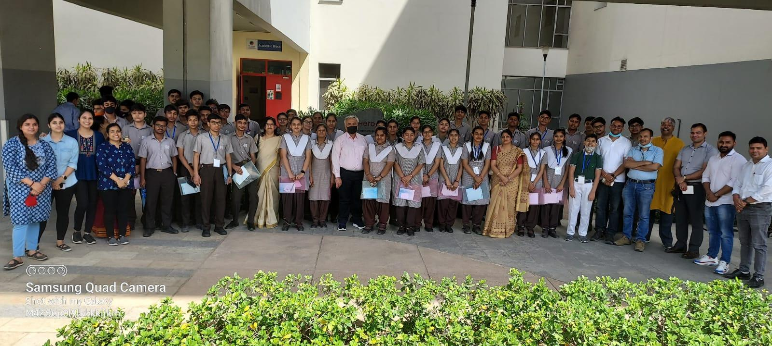

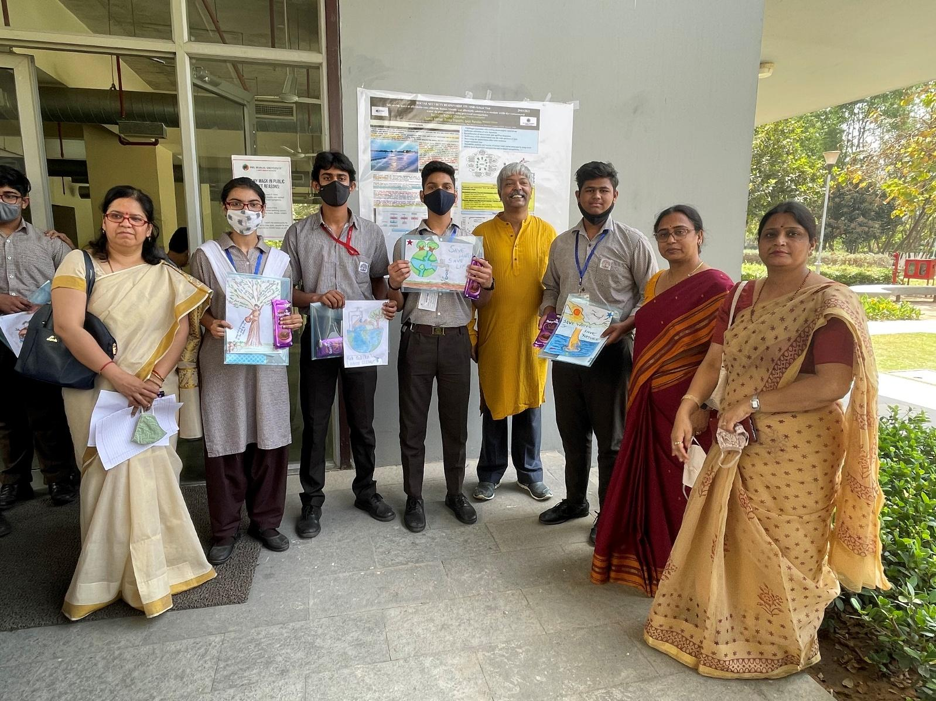

First Prize winners on painting related to project theme (water treatment/ water conservation)

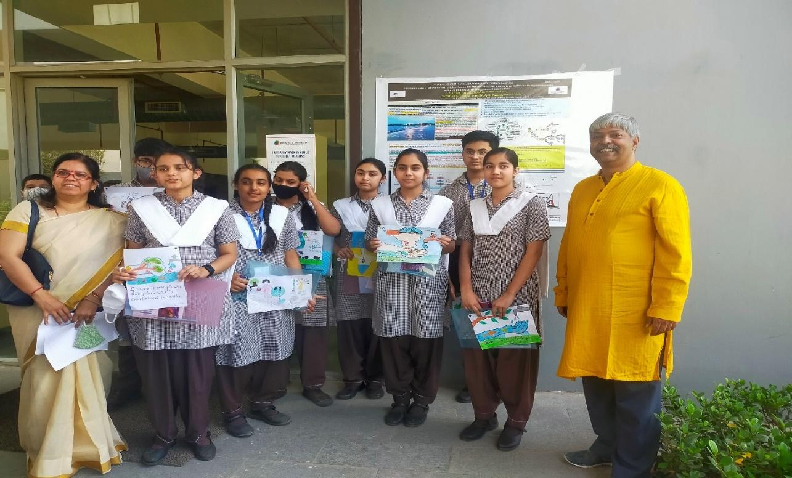
Second Prize winners on painting related to project theme (water treatment/ water conservation)

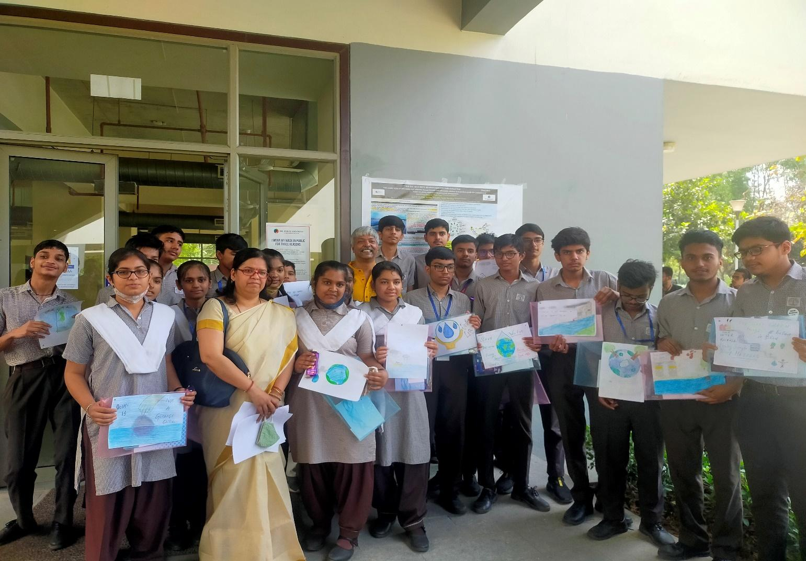
Third Prize winners on painting related to project theme (water treatment/ water conservation)

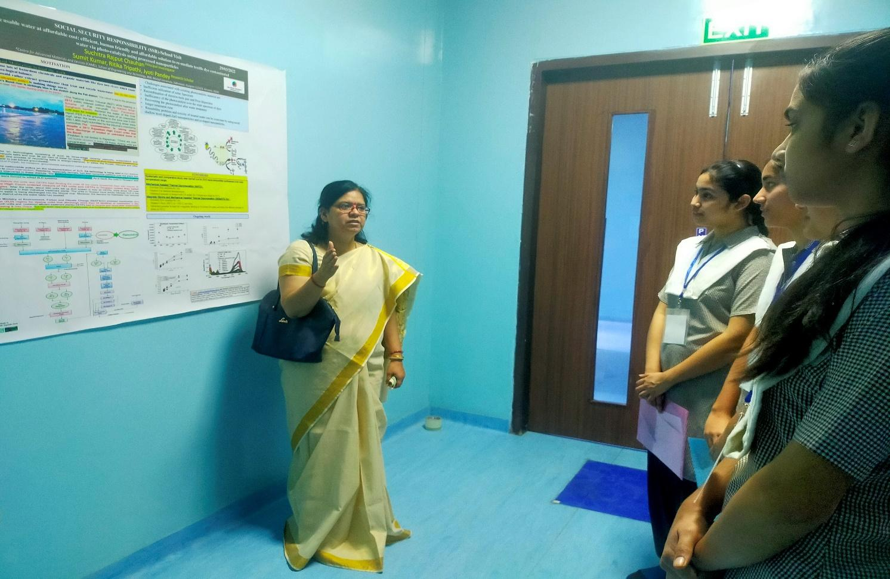
Project work explaination to the students
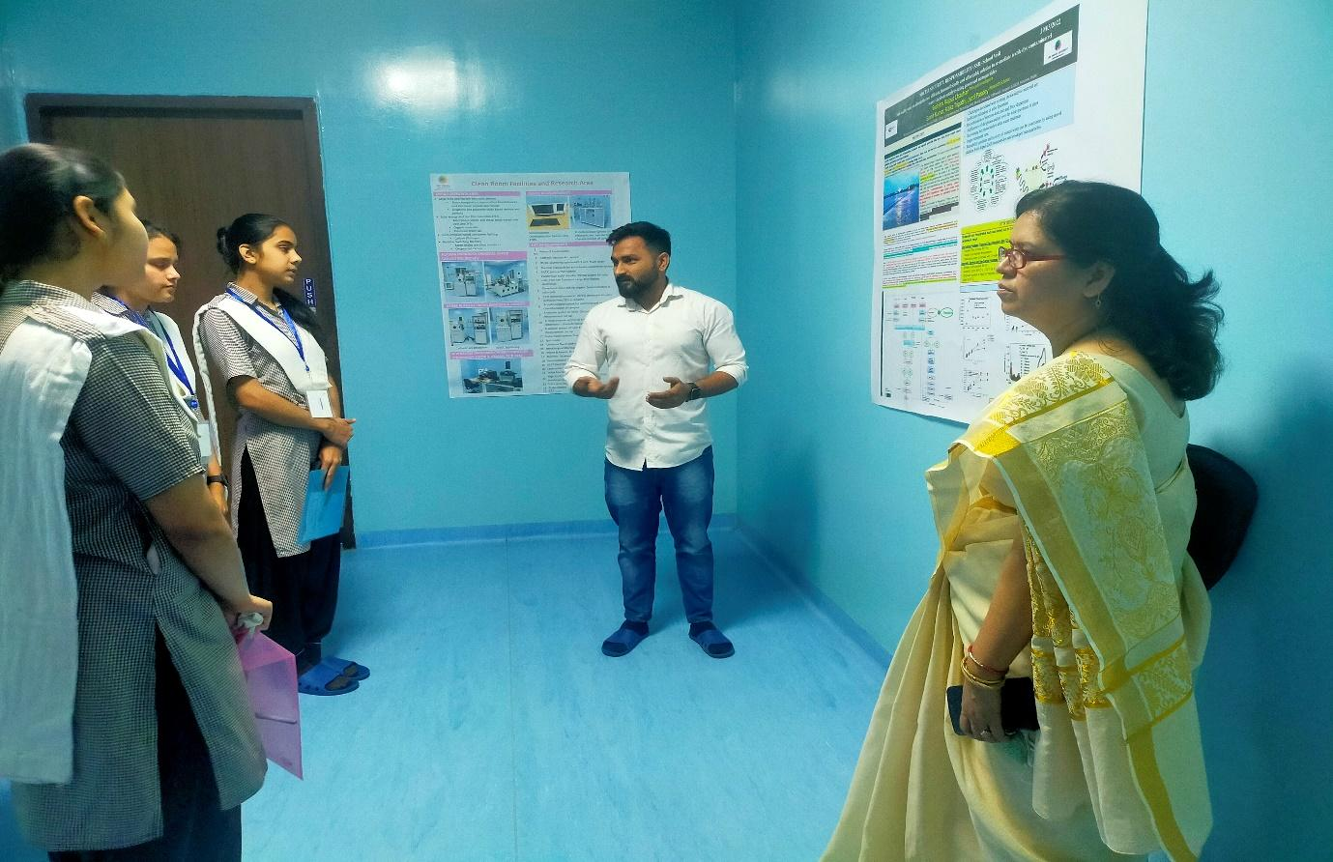
Project work explanation to the students
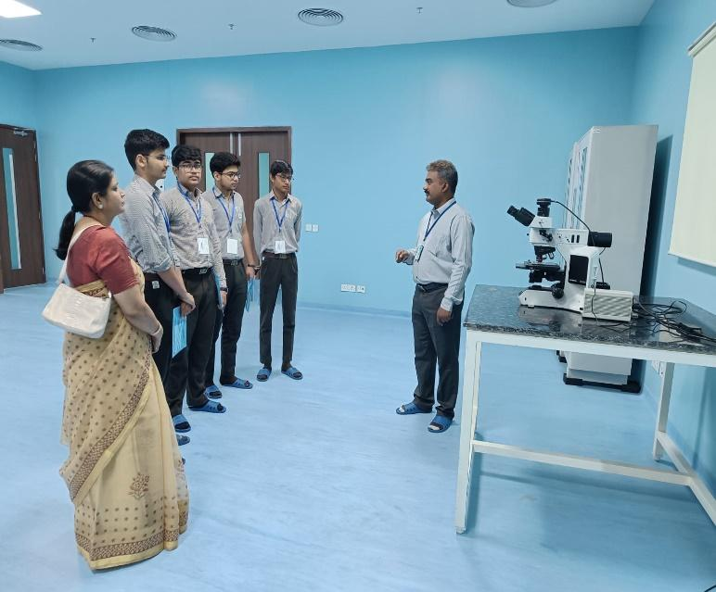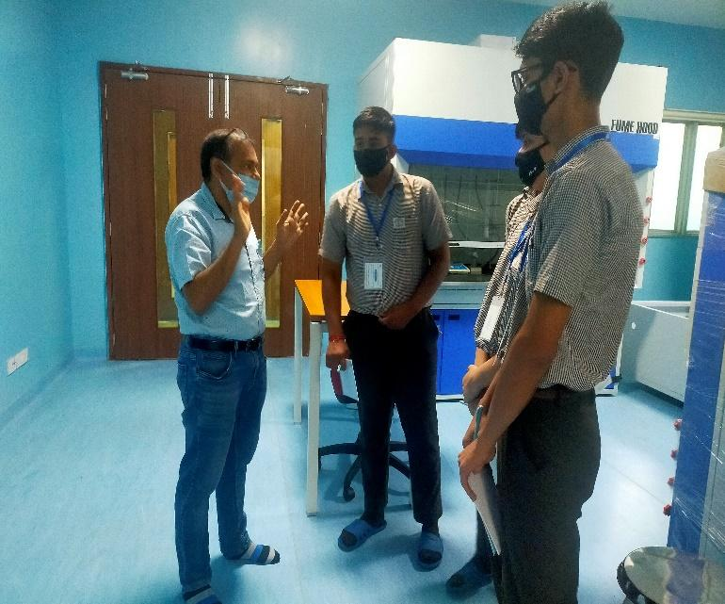
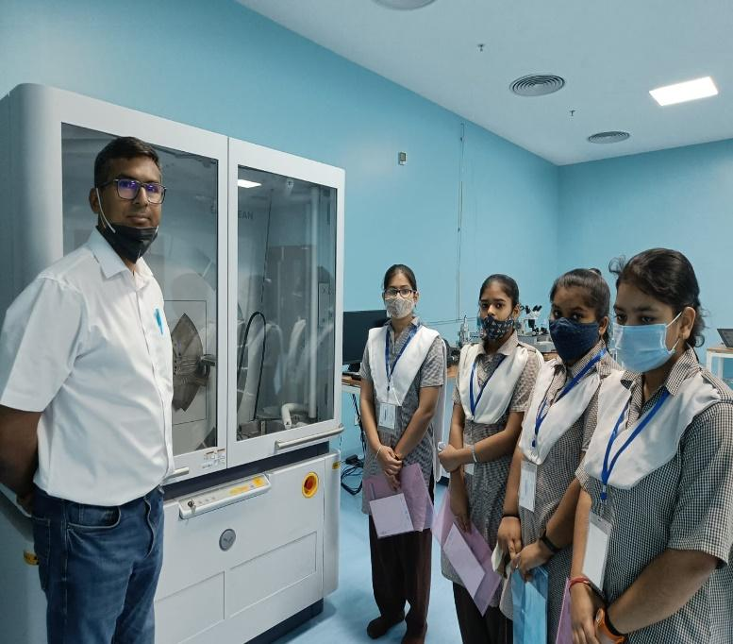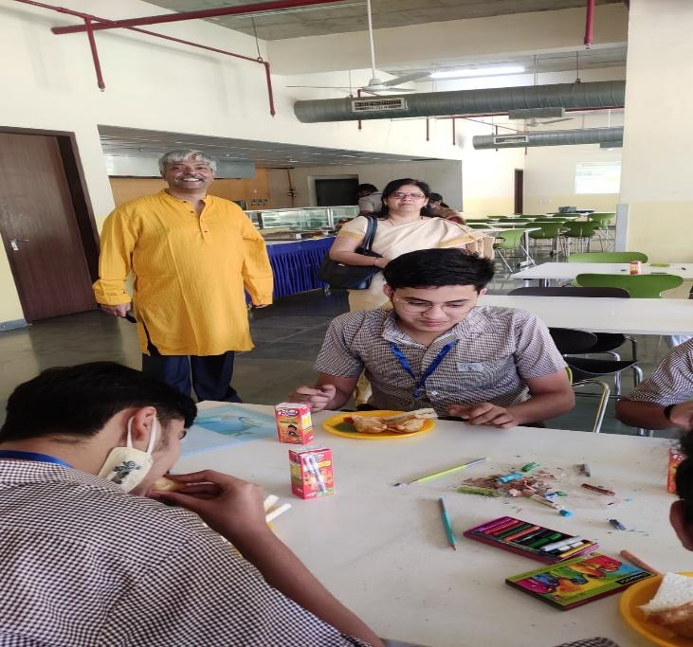
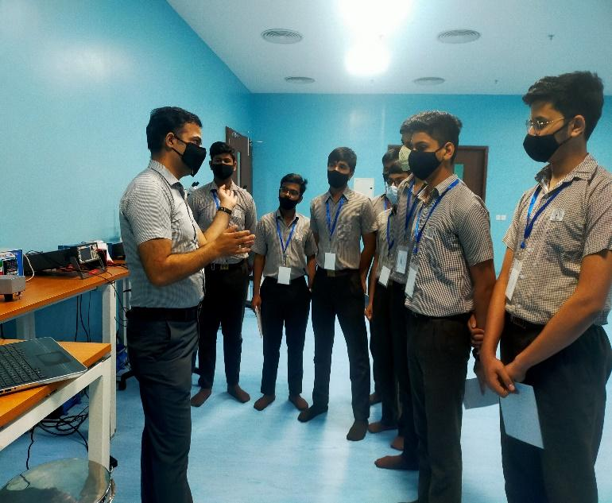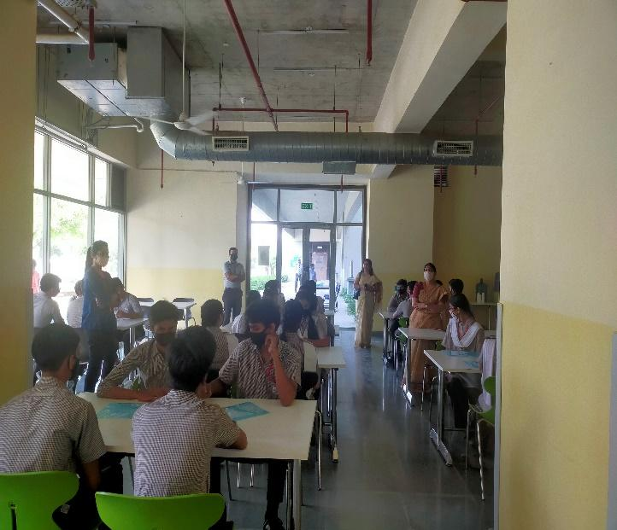
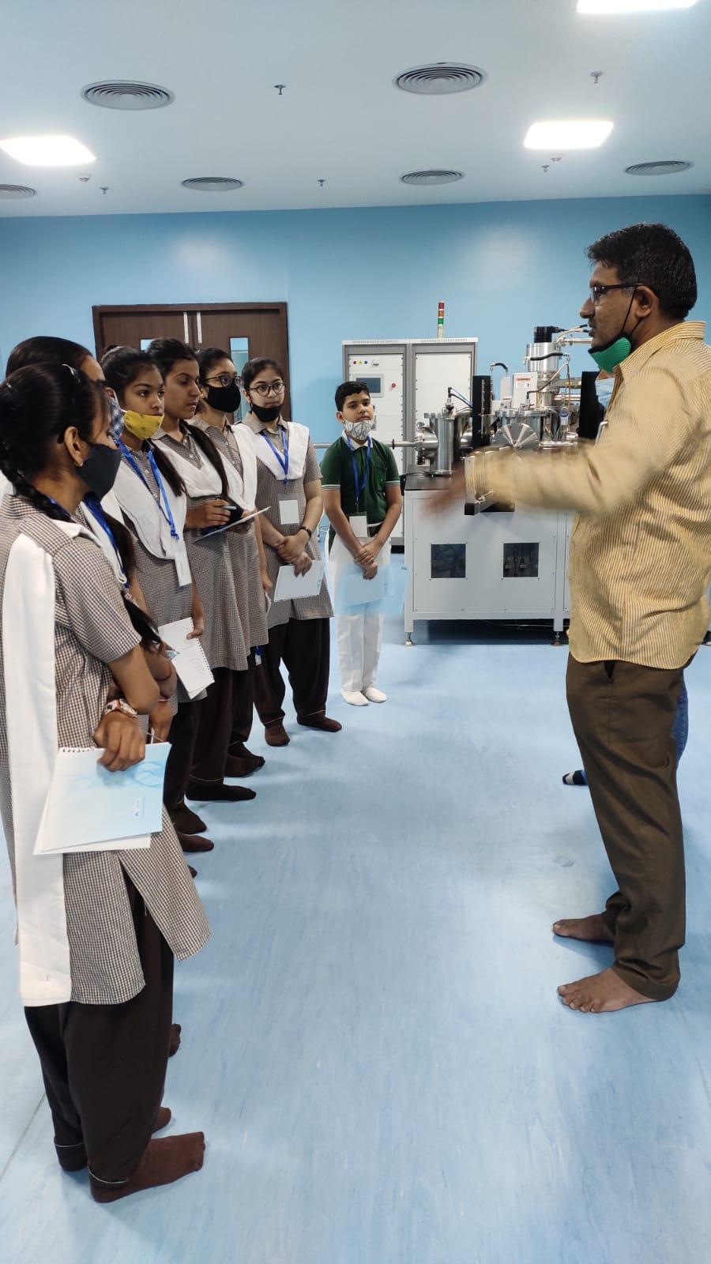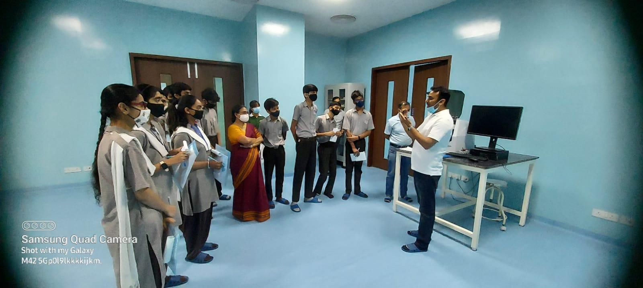
Interaction with researchers and faculty at BMU

Mandatory Annexures:

- Attendance Sheet
- Financial Transaction Proofs

Prepared by: Approved by:

Name: _Dr Suchitra Rajput Chauhan_____ Name: Prof Anirban Chakraborti___
Designation: _Assistant Professor_______ Designation: DEAN SOET_
Date: ___10-April 2022_____________ Date: 11-4-2022

